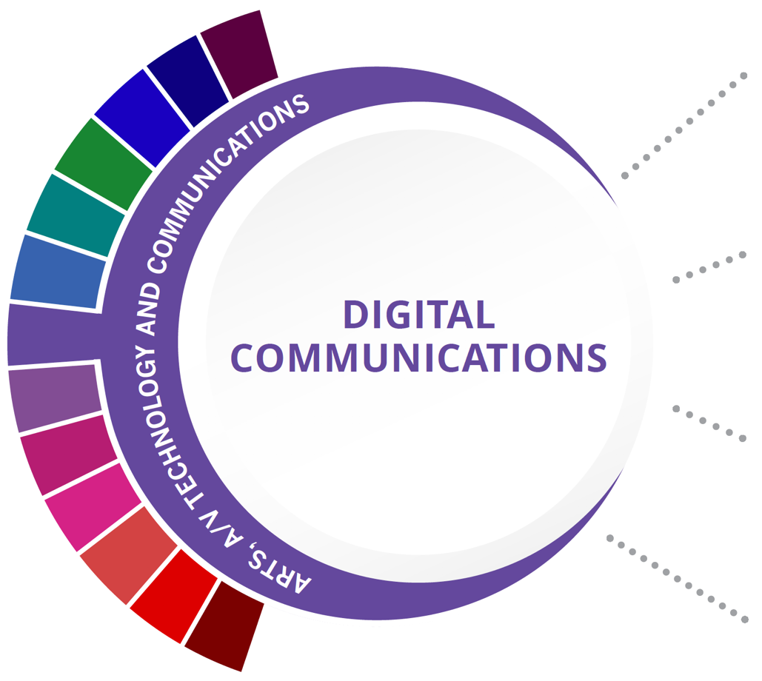
Statewide Program of Study: Digital Communications; Arts, A/V Technology and Communications Career Cluster
Level 1 | Principles of Arts, A/V Technology, and Communications
Level 2 | Audio/Video Production I/Lab
Level 3 | Audio Video Production II/Lab
Level 4

HIGH SCHOOL/ INDUSTRY CERTIFICATION | CERTIFICATE/ LICENSE* | ASSOCIATE’S DEGREE | BACHELOR’S DEGREE | MASTER’S/ DOCTORAL PROFESSIONAL DEGREE
Apple Final Cut Pro X | Certified Video Engineer | Recording Arts Technology/  Technician | Recording Arts Technology/  Technician | Communications Technology/ Technician
Apple Logic  Pro X | Commercial Audio Technician | Cinematography and Film/  Video Production | Cinematography and Film/  Video Production | Cinematography and Film/  Video Production
Adobe Certified Associate Premiere Pro | Certified AM Directional Specialist | Radio and Television Broadcasting Technology/  Technician | Radio and Television | Radio and Television
Adobe Certified Associate Certifications | Certified Broadcast Radio Engineer | Music Technology | Agricultural Communication/ Journalism | Agricultural Communication/ Journalism
Additional industry-based certification information is available on the TEA CTE website. For more information on postsecondary options for this program of study, visit TXCTE.org.
Occupations | Median Wage | Annual Openings | % Growth
Sound Engineering Technicians | $39,562 | 79 | 27%
Camera Operators, Television, Video and Motion Picture | $50,024 | 129 | 9%
Audio and Video Equipment Technicians | $40,581 | 757 | 29%
Film and Video Editors | $47,382 | 118 | 23%

WORK BASED LEARNING AND EXPANDED
LEARNING OPPORTUNITIES
Exploration Activities: | Work Based Learning  Activities:
Shadow a production team  Participate in SkillsUSA or TSA | Intern at a local television station or video production company  Work with a local company on a project

The Digital Communications program of study explores the occupations and educational opportunities associated with the production of audio and visual media formats for various purposes, such as TV broadcasts, advertising, video production, or motion pictures. This program of study may also include exploration into operating machines and equipment to record sound and images, such as microphones, sound speakers, video screens, projectors, video monitors, sound and mixing boards, and related electronic equipment.

Statewide Program of Study: Digital Communications; Arts, A/V Technology and Communications career cluster
The Arts, A/V Technology and Communications (AAVTC) Career Cluster focuses on careers in designing, producing, exhibiting, performing, writing, and publishing multimedia content including visual and performing arts and design, journalism, and entertainment services. Careers in the AAVTC career cluster require a creative aptitude, a strong background in computer and technology applications, a strong academic foundation, and a proficiency in oral and written communication.

Successful completion of the Digital Communications program of study will fulfill requirements of the Business and Industry Endorsement. Revised - March 2022

COURSE INFORMATION

COURSE  NAME | SERVICE ID | PREREQUISITES (PREQ)  COREQUISITES (CREQ) | Grade
Principles of Arts, A/V Technology, and Communications | 13008200 (1 credit) | None | 9
Audio/Video Production I/Lab | 13008500 (1 credit)  13008510 (2 credits) | None | 10-12
Audio Video Production II/Lab | 13008600 (1 credit)  13008610 (2 credits) | PREQ: Audio/Video Production I | 10-12

FOR ADDITIONAL INFORMATION ON THE ARTS, AUDIO/VIDEO, TECHNOLOGY, AND COMMUNICATIONS CAREER CLUSTER, PLEASE CONTACT: CTE@tea.texas.gov
https://tea.texas.gov/cte

(District) offers career and technical education programs in (types of programs offered). Admission to these programs is based on (admission standards). It is the policy of (District) not to discriminate on the basis of race, color, national origin, sex or handicap in its vocational programs, services or activities as required by Title VI of the Civil Rights Act of 1964, as amended; Title IX of the Education Amendments of 1972; and Section 504 of the Rehabilitation Act of 1973, as amended. It is the policy of (District) not to discriminate on the basis of race, color, national origin, sex, handicap, or age in its employment practices as required by Title VI of the Civil Rights Act of 1964, as amended; Title IX of the Education Amendments of 1972; the Age Discrimination Act of 1975, as amended; and Section 504 of the Rehabilitation Act of 1973, as amended. (District) will take steps to assure that lack of English language skills will not be a barrier to admission and participation in all educational and vocational programs. For information about your rights or grievance procedures, contact the Title IX Coordinator at (physical address of Coordinator) (email address of Title IX Coordinator), (phone number of Title IX Coordinator), and the Section 504 Coordinator at (physical address of Coordinator), (email address of Section 504 Coordinator), (phone number of Section 504 Coordinator)

